Enterprise Application Development CA3
Jason O’Connor – X00191019

Description of System:
For my project, I have decided to use the RAWG API which is a video game database API that contains over 500,000 games. It includes details such as their cover art, release dates, genres, and so on.
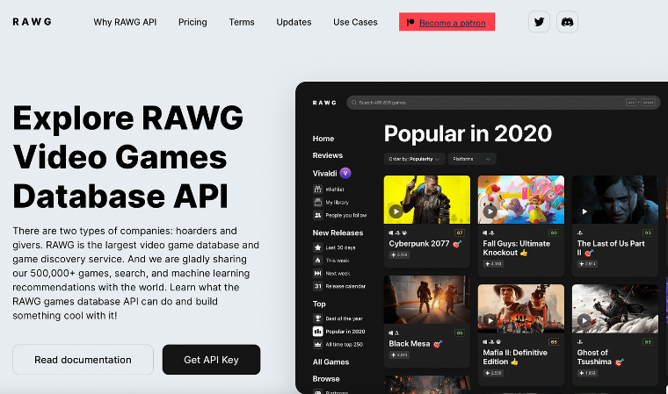
Using this API, the basis for my project would be an adaptable application, suitable for both mobile and desktop devices, where the user can use a search function to find video games using this API and learn about them.
Taking advantage of the API, I allow the user to search the database using keywords or full titles, while also having the alphabet filters above to display only games starting with the chosen letter, and a list of all video games matching the searches is returned.
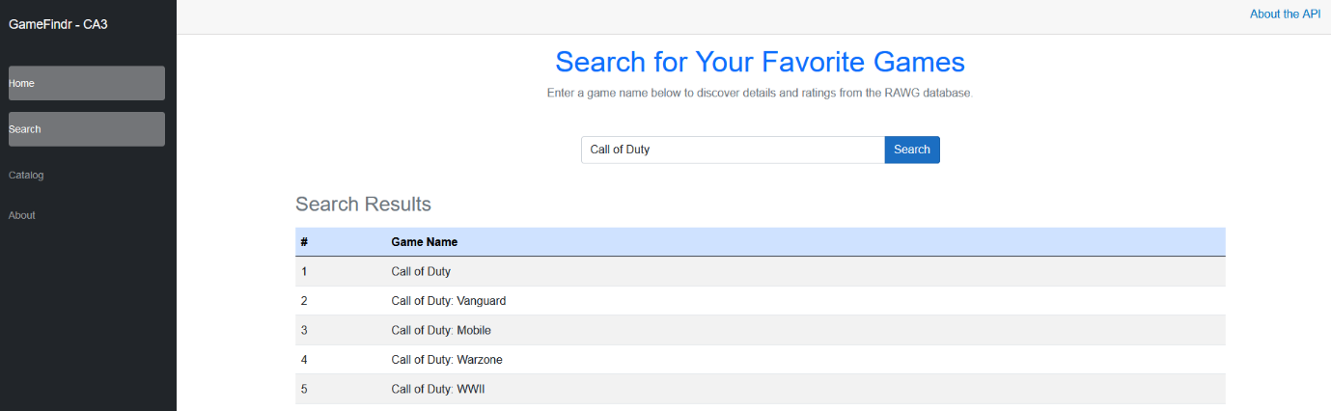
This project is being created using Blazor, but I have tried my best to make sure this project scales well depending on the screen size and that all content is visible and easy to understand.
The code behind the project is calling from the RAWG API, using a key which I acquired by creating an account and enquiring for one, and this provides my project with the titles, images, and information about video games styled in lists that are easy to read, and I used pagination to ensure there is not an information overload. The RAWG API is free and allows me to use anything up to 20,000 calls, which is plenty for the use of this project.
My project contains four pages which are Home, About, Search, Catalogue. Considering the brief for this project, I deemed these sufficient to complete the project and was happy to work on making them the best I could. The search page allows the user to type in the name of a game they wish to find, and in a tabular format the results are displayed. The catalogue page contains filters of the alphabet letters that when clicked, display all video games starting with that letter, and pagination allows the user to move through pages, keeping the results to less than 20 per page.
Description of Testing:
For the testing of this application, I used the Postman API testing software to ensure that my API was working as intended. Firstly, I found the GET url that I would need to test this request and added it to the GET box, then added a header for Authorization and put in my API Key I requested from RAWG and then I was presented with a positive response, with information being received and printed in the json box below.
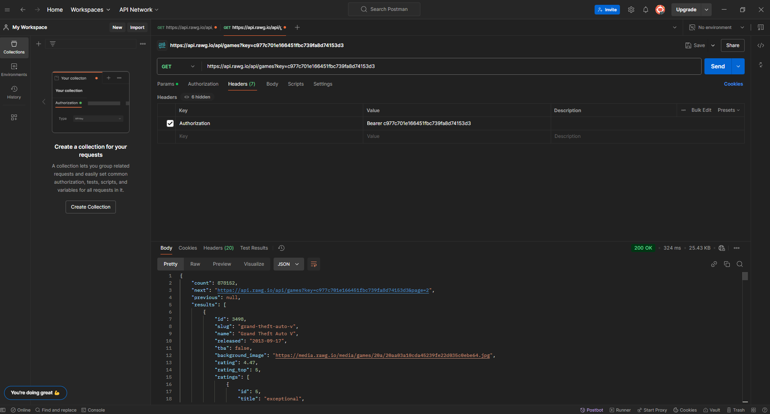
The next piece of testing I carried out is using Selenium IDE. After launching the website through Visual Studio 2022, I used the IDE to create some tests to ensure my features worked correctly. Starting with the Catalog, I ensured the user could navigate from the Home page to the Catalog page, and then use the filters to change pages and sort games.
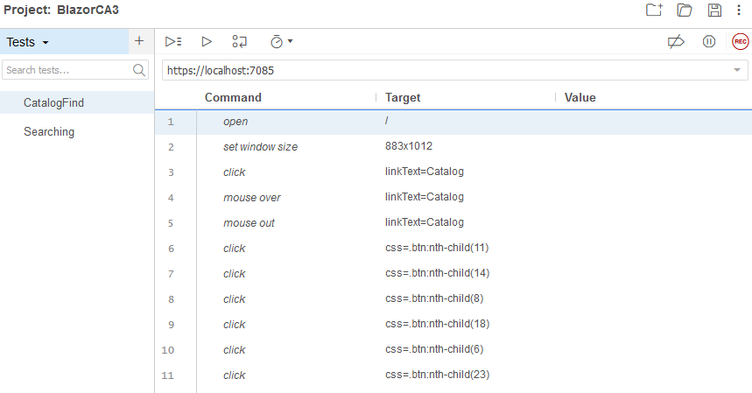
The next test I carried out, still using this IDE, was on the search bar. Again, testing the navigation from the Home page to the Search page, then inputing some text and receiving a result and the table printing without any issues.
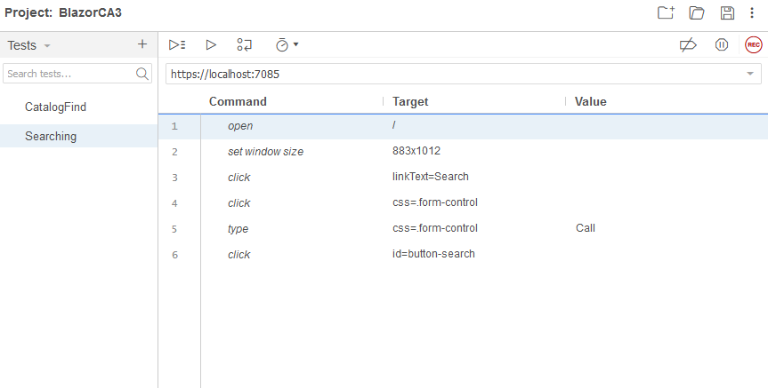

GitHub Repo URL:
https://github.com/UselessPlank/EntAppCA3

